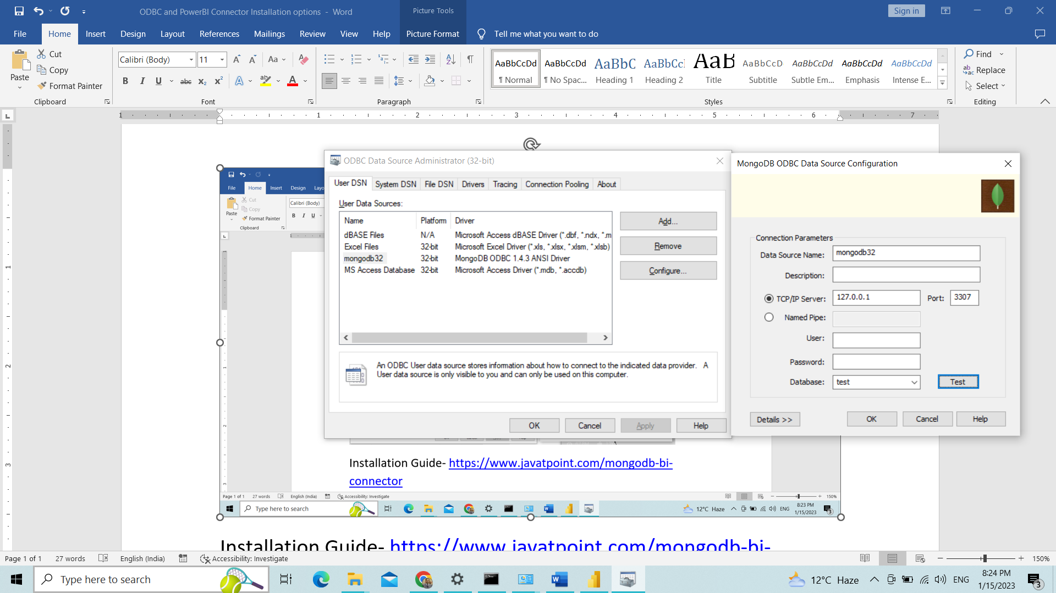

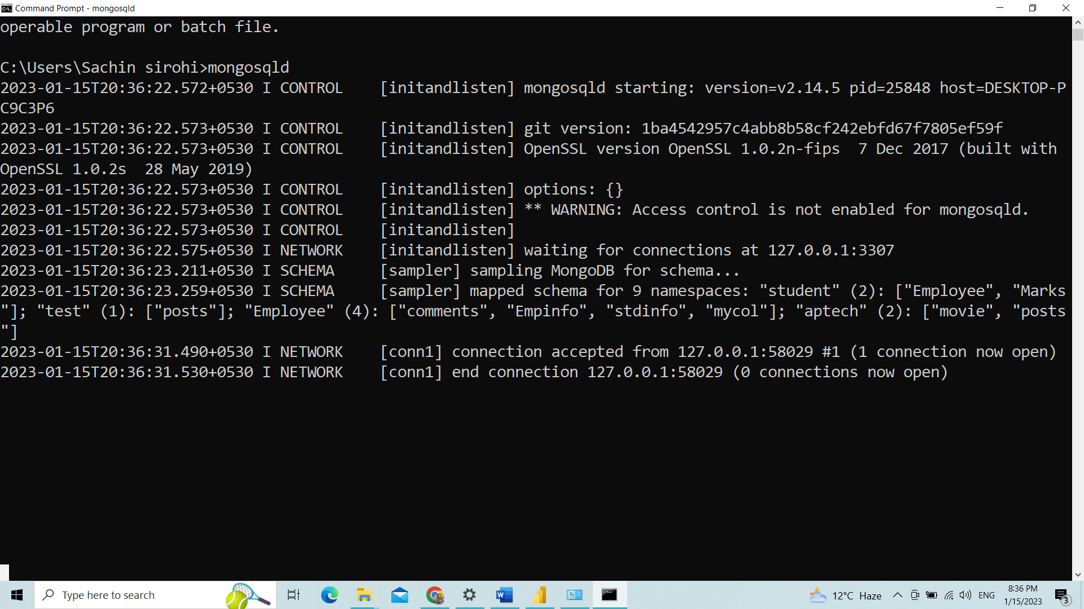

Before run set path to environment

When you are trying to test odbc database testing first start – mongosqld

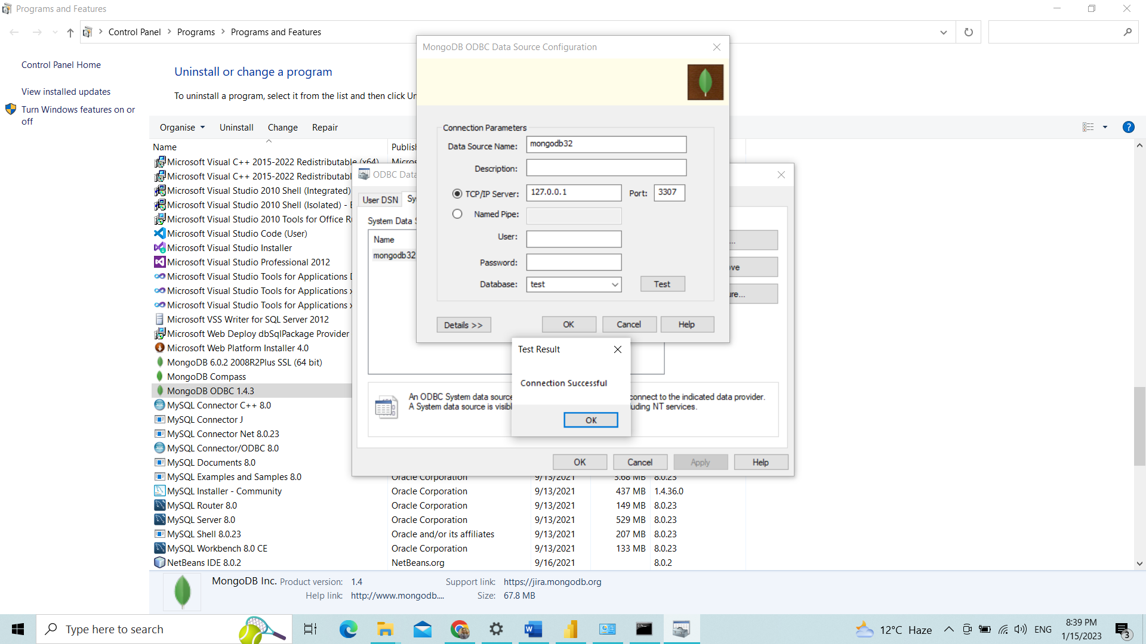

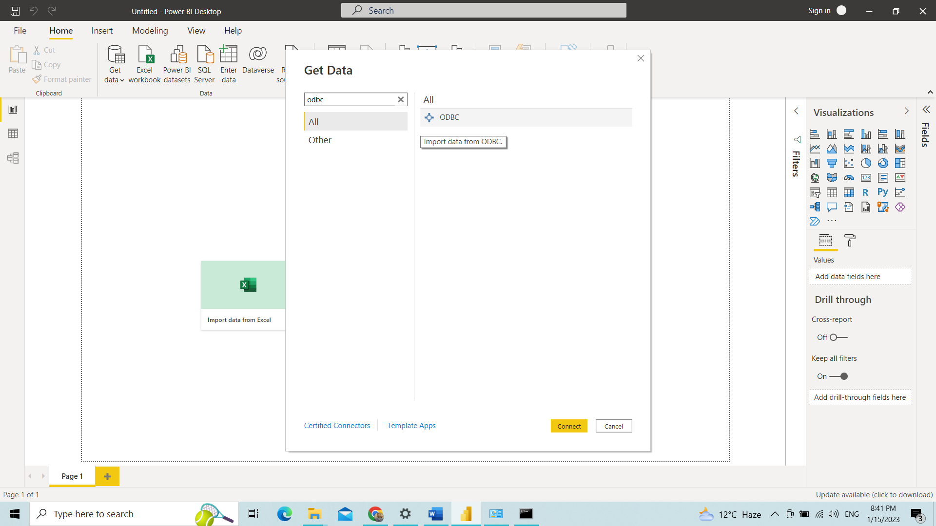

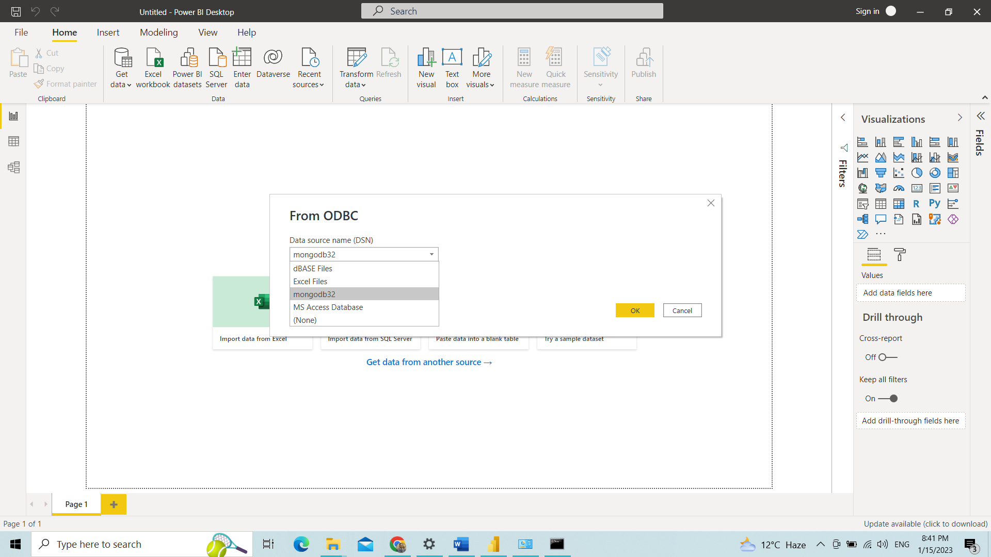

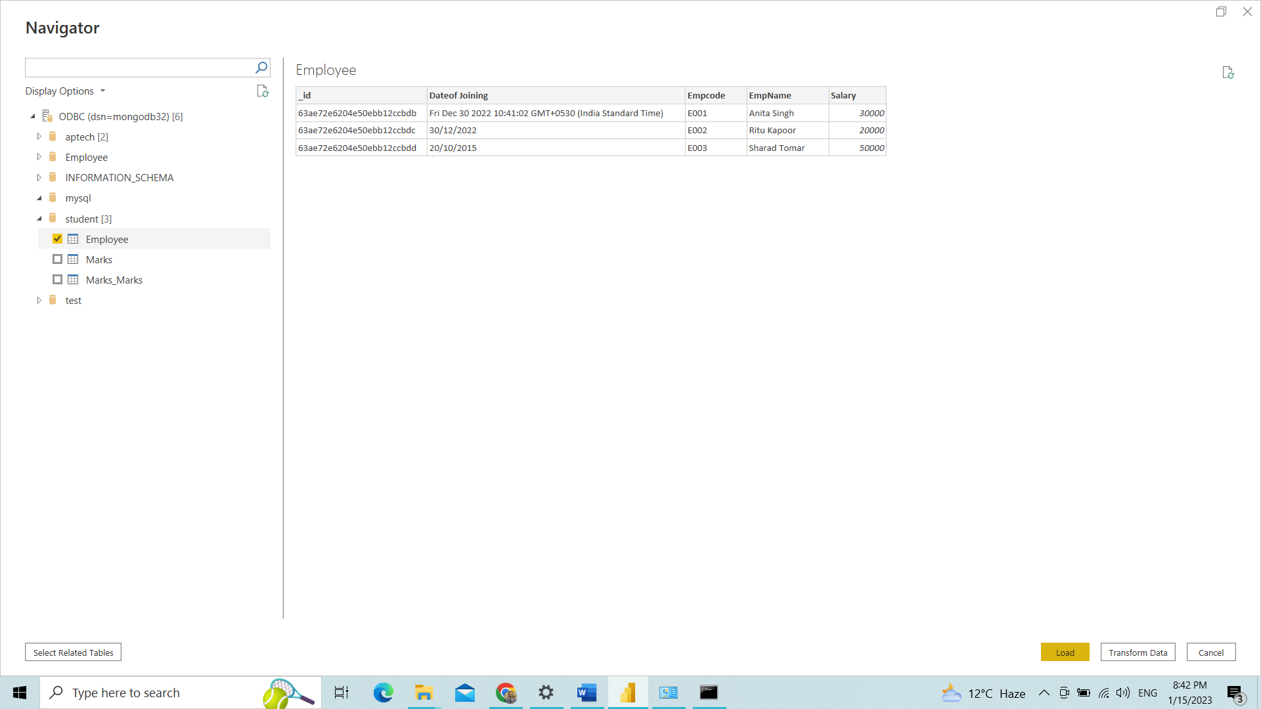

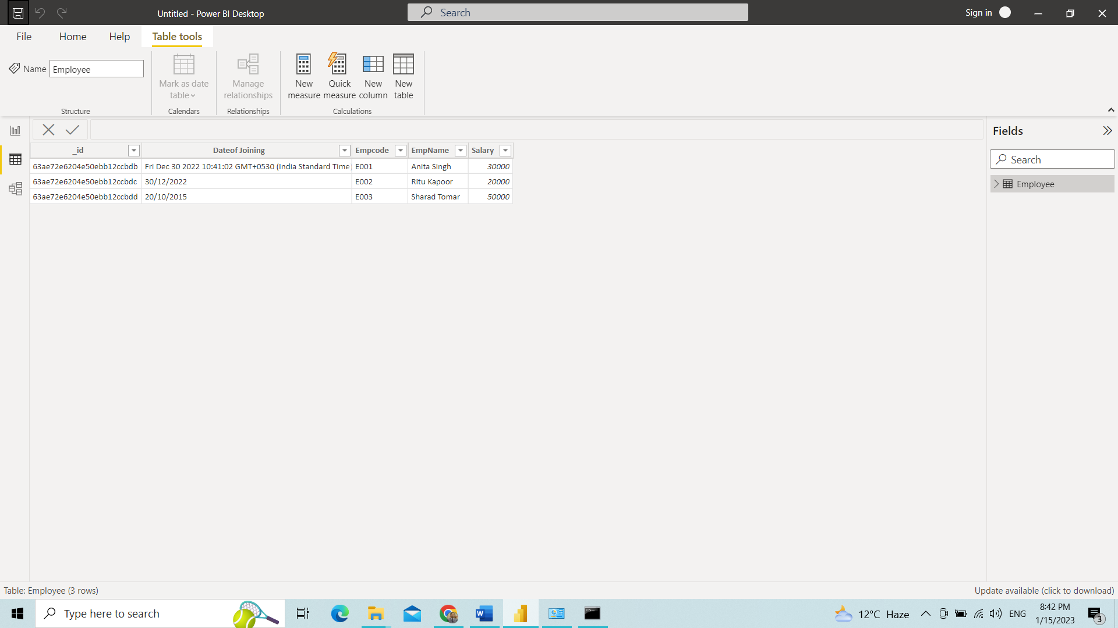

Installation Guide- <https://www.javatpoint.com/mongodb-bi-connector>

Download and Install Community - <https://www.mongodb.com/try/download/compass>

Download and Install- <https://github.com/mongodb/mongo-bi-connector-odbc-driver/releases/>

Download odbc 32bit.msi or 64bit.msi

Download and Install BI Connection- <https://www.mongodb.com/try/download/bi-connector>

ODBC Guide- <https://www.mongodb.com/docs/bi-connector/master/tutorial/create-system-dsn/#std-label-create-system-dsn-bi-connector>